**Basic Electrical Science Lab  
Course Code: EE152**

**Laboratory Manual**

Name:

Roll No.:

Section:

Academic Session: April – August 2021

**National Institute of Technology Goa**



**CERTIFICATE**

This is to certify that Mr./ Ms. _____________________ of Class B.Tech 1st year (2nd Sem), Division Sec A/B, bearing Roll. No._____________, has satisfactorily completed the course experiments in the Laboratory Course Basic Electrical Science Lab (EE152) in the academic year 2020-2021 in the Institution of National Institute of Technology Goa.

**Course Instructor**

**Table of Contents**

|  |  |  |  |  |  |
| --- | --- | --- | --- | --- | --- |
| **Sl. No.** | **Name of the Experiment** | **Pg. No.** | **Date of Experiment** | **Date of Submission** | **Marks/Expt.**  **(10 M)** |
| **1** | **Verification of Ohms Law** | **04** | **20-05-2021** |  |  |
| **2** | **Verification of Kirchhoff's Laws – KVL and KCL** | **07** |  |  |  |
| **3** | **Verification of Thevenin’s and Norton’s Theorem** |  |  |  |  |
| **4** | **Measurement of AC System quantities – Average, RMS, Form Factor, Peak Factor, P, Q, pf** |  |  |  |  |
| **5** | **Measurement of Self, Mutual and Coefficient of Coupling** |  |  |  |  |
| **6** | **V-I Characteristics of P-N Junction and Zener Diode** |  |  |  |  |
| **7** | **Half-wave Diode Rectifier** |  |  |  |  |
| **8** | **Full-wave Diode Rectifier** |  |  |  |  |
| **9** | **Transient analysis of RL, RC and RLC Circuits** |  |  |  |  |
| **10** | **Digital Gate Circuits** |  |  |  |  |

**Experiment 1**

**Verification of Ohms Law**

1. **Aim**: To verify Ohms Law for the given circuit
2. **Software tools required:** MATLAB/SIMULINK
3. **Simulink Block sets Used:** Powergui, DC Voltage Source, Series RLC Branch, Current Measurement, Voltage Measurement, Display, Scope, XY Graph, Controlled Voltage Source, Ramp
4. **Theory**: Ohms Law states that the voltage across conducting materials is directly proportional to the current through the material. one arrives at the usual mathematical equation that describes this relationship

V α I

* V = IR

Where, V – Voltage across the element

I – Current flowing through the element

R - Resistance offered by the element

R is also the slope of the straight line when V-I characteristics are plotted. Normally resistance is a positive quantity.

1. **Circuit Diagram:** The considered circuit for Ohms law verification is as given in fig. 1a. The connected circuit in MATLAB/Simulink is given in Fig.1b.

100 V

20 Ω

(0-5 A)

(0-100 V)

**Fig1a**: Circuit Diagram

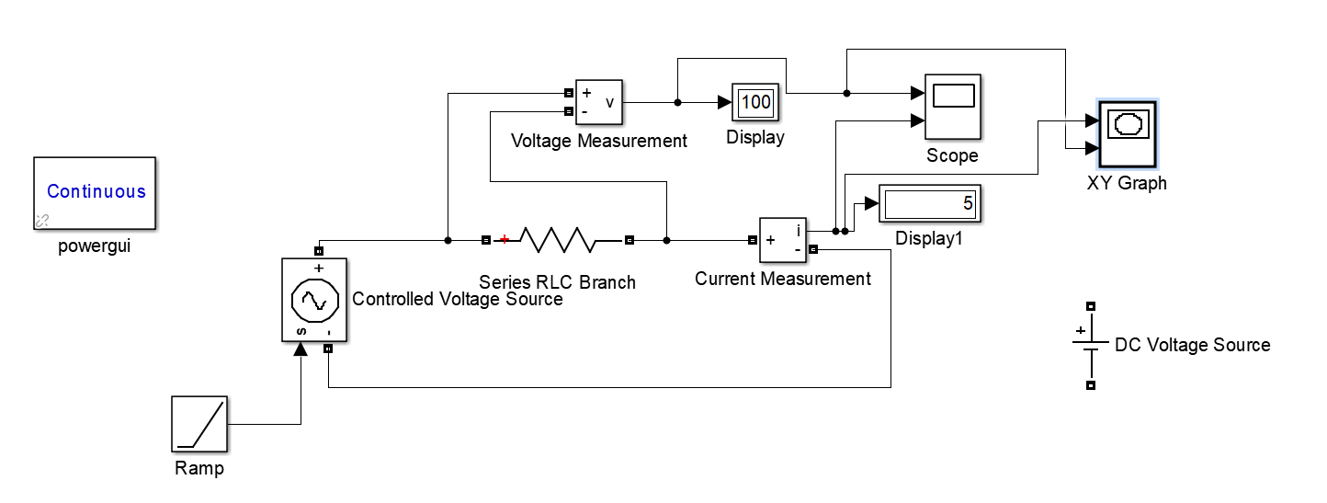

**Fig1b**: Circuit connections in Simulink

1. **Procedure:**
2. The mentioned Simulink blocksets are connected as shown in Figure 1b.
3. Apply the specified voltage across the specified resistance
4. Measure the current flowing through the resistor
5. V-t, I-t and V-I plots are generated
6. The same procedure is repeated for specified types of inputs like Constant DC, Ramp, etc.
7. **Graphical Results:**

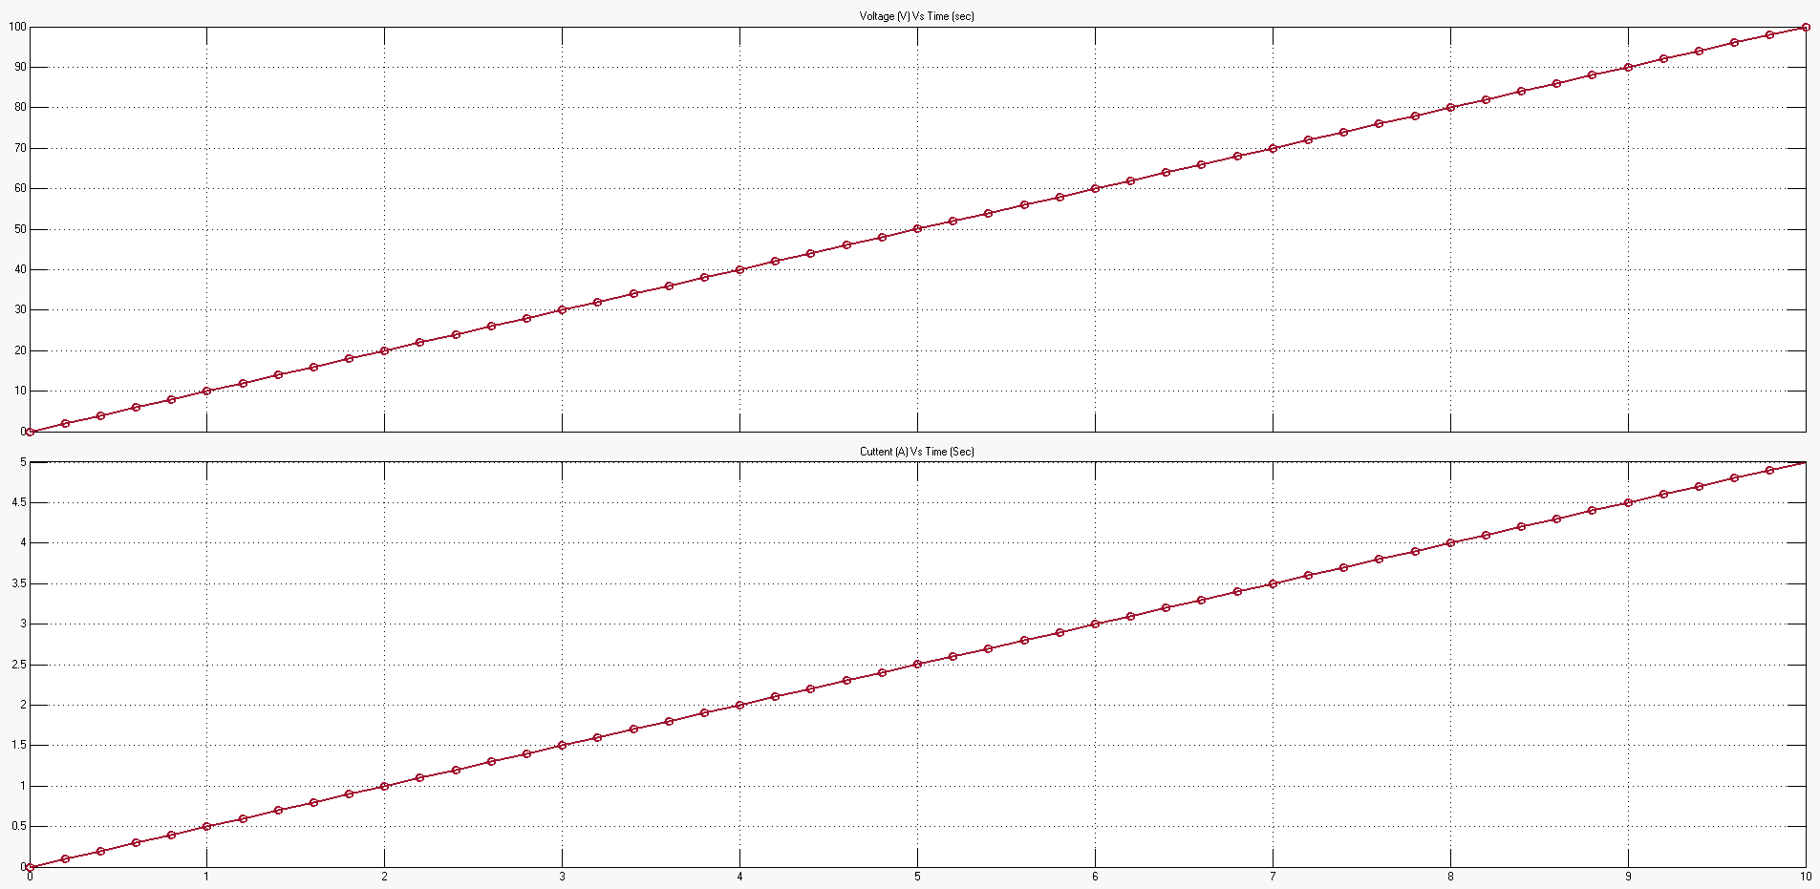

**Fig.2a:** Voltage Vs Time and Current Vs time Plots

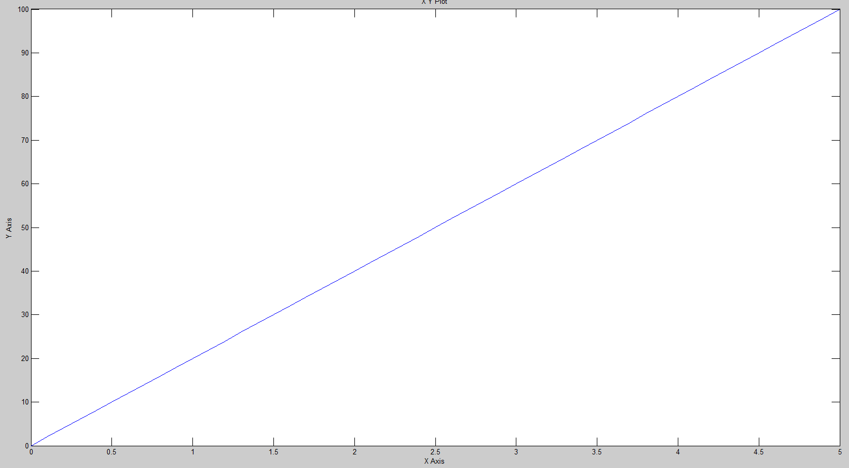

**Fig2b:** V-I Characteristics

1. **Precautions:**
2. Ensure that ‘powergui’ block set is included in the Simulink file
3. Ensure that connections are properly made
4. Ensure that the scale of the graphs should be adjusted to the range in which the readings vary
5. **Inferences**: From the output, it can be inferred that as the input ramp is varied from 0-100 V, the current through the resistance varies from 0-5 A.
6. **Conclusion:** The Ohms law is verified for all the specified inputs for the studied resistive network.

**Assignment:**

* 1. Consider the below Step function as input with R = 5Ω

V(t) = 50V 0 ≤ t ≤ 5 sec

= -50V 5 ≤ t ≤ 10 sec

* 1. Consider the Ramp function varying from 0-200 V as input with R = 50Ω

**Experiment 2**

**Verification of Kirchhoff's Laws – KVL and KCL**